

Report

© Epic Atlantic Limited
Epic Atlantic Limited
12 Kenneth Agbakuru Street, Lekki Phase I, Lagos, NG
www.epicatlantic.com | info@epicatlantic.com | +234 809 835 1008
This report contains confidential information and is intended only for the use of the individual named above. If you are not the named addressee you should not disseminate, distribute or copy this report without authorization.

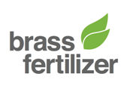


SPDC-BFPC UPSTREAM GAS SUPPLY, GATHERING,
EVACUATION & PROCESSING (UGS-GEP) PROJECT

Infrastructural Support Strategy & Manning
Gas Gathering & Evacuation Pipelines

© Epic Atlantic Limited

Epic Atlantic Limited
12 Kenneth Agbakuru Street, Lekki Phase I, Lagos, NG
www.epicatlantic.com | info@epicatlantic.com | +234 809 835 1008

This report contains confidential information and is intended only for the use of the individual named above. If you are not the named addressee you should not disseminate, distribute or copy this report without authorization.
© Epic Atlantic Limited

Epic Atlantic Limited
12 Kenneth Agbakuru Street, Lekki Phase I, Lagos, NG
www.epicatlantic.com | info@epicatlantic.com | +234 809 835 1008

This report contains confidential information and is intended only for the use of the individual named above. If you are not the named addressee you should not disseminate, distribute or copy this report without authorization.

Prepared for:
Brass Fertilizer & Petrochemical Company Limited
Doc. No: EA/SPDC-BFPC UGS-GEP/AMP/RPT-001

Endorsed by:
Aloy Onyenucheya Duru, COREN (R.7580)
12th April 2017

© Epic Atlantic Limited

Epic Atlantic Limited
12 Kenneth Agbakuru Street, Lekki Phase I, Lagos, NG
www.epicatlantic.com | info@epicatlantic.com | +234 809 835 1008

This report contains confidential information and is intended only for the use of the individual named above. If you are not the named addressee you should not disseminate, distribute or copy this report without authorization.

© Epic Atlantic Limited

Epic Atlantic Limited
12 Kenneth Agbakuru Street, Lekki Phase I, Lagos, NG
www.epicatlantic.com | info@epicatlantic.com | +234 809 835 1008

This report contains confidential information and is intended only for the use of the individual named above. If you are not the named addressee you should not disseminate, distribute or copy this report without authorization.
© Epic Atlantic Limited

Epic Atlantic Limited
12 Kenneth Agbakuru Street, Lekki Phase I, Lagos, NG
www.epicatlantic.com | info@epicatlantic.com | +234 809 835 1008

This report contains confidential information and is intended only for the use of the individual named above. If you are not the named addressee you should not disseminate, distribute or copy this report without authorization.
Statement of Confidentiality
This Conceptual Study Report may contain confidential and proprietary business information of Parties involved in this project. These materials may be printed or photocopied for use in evaluating the proposed project, but are not to be shared with other parties.
Epic Atlantic Limited | 12 Kenneth Agbakuru Street | Lekki Phase I, Lagos, NG | www.epicatlantic.com | info@epicatlantic.com
SUMMARY PAGE
Client: BRASS FERTILIZER & PETROCHEMICAL COMPANY LIMITED.
Project: SPDC-BFPC UGS-GEP | Title: Infrastructural Support Strategy & Manning
Facilities: Gas Gathering, Evacuation & Processing Systems | Doc No: EA/SPDC-BFPC UGS-GEP/AMP/RPT-001-A01

The administration of this document is in respect of the Infrastructural Support Strategy & Manning of the SPDC-BFPC Upstream Gas Supply, Gathering, Evacuation and Processing (UGS-GEP) Project.
The document defines services to be rendered and management of the facilities that will form the basis of the project’s Front End Engineering Design (FEED).
It is also an input & accompaniment to the conceptual study and basic design reports & presentations to DPR as procedural and statutory requirements in the process of securing regulators’ approval to progress to the FEED / Detail Design that will lead to the project’s FID and implementation.
The report was produced using data and reference documents provided by client, and if further document and information become available, Epic Atlantic reserves the right to update the opinion set out in this report.
For better appreciation, this document should be read in conjunction with the references listed below, which are the Concept Select Study reports that constitute basis for the Conceptual Study.
KEY WORDS: bulklines, maintenance, operations, pipelines, strategy

REferences
Document No. | Description
TO-D-AA-00001 | Basis for Design
EA/SPDC-BFPC UGS-GEP/CSM-RPT-002 | Gas Gathering & Surface Facilities Concept Screening Study
EA/SPDC-BFPC UGS-GEP/SVY-RPT-001 | Pipeline Route Selection Study

Table of Contents
1. Administration 8
1.1. Validity & Change Management 8
1.2. Background 9
1.3. Scope of Document 10
2. Introduction 11
2.1. The Organisational Structure 12
2.2. Project Description 13
3. Infrastructural Support Strategy & Manning 14
3.1. Strategy for Base Facilities 14
3.2. Strategy for Transportation to Remote Locations 14
3.3. Strategy for Operational Materials & Consumables 14
3.4. Strategy for Security Systems 15
3.5. Strategy for Pipeline Database Management System 15
3.5.1. Strategy for the Selection of Database 16
3.6. Operation and Maintenance Philosophy 16
3.6.1. Compliance to Project Specifications 17
3.6.2. Operations Philosophy 17
3.6.3. Maintenance Philosophy 17
3.6.4. Abnormal Situation Management 18
3.6.5. Emergency and Contingency Plan 18
3.7. Inspection and Maintenance Strategy 19
3.8. Strategy for Safety Systems 20
3.9. Strategy for Communication Systems 20
3.10. Strategy for ROW Preservation, Elimination of Third Party Intrusion and Safety 21
APPENDIX 22
Appendix-1: Well Gas Gathering Schematics 22
Appendix-2: Proposed Pipeline Route 22
Appendix-3: Pipeline Materials Selection 22

List of Figures
Figure 2.1: Organisational Structure of the Brass Fertilizer and Petrochemical Company Asset Management 12
Figure 2.3: Wellhead Gas Gathering Schematics and Gas Process Flow Schematics to the Petrochemical Plant and Power Plant 13

Glossary
The following definitions and abbreviations have been used in this document.
Organisational Terms
AKAB | Akabel
API | American Petroleum Institute
ASME | American Society of Mechanical Engineers
BFPC | Brass Fertilizer & Petrochemical Company Limited
DPR | Department of Petroleum Resources
EAL | Epic Atlantic Limited
EIL | Engineers India Limited
IP | The Institute of Petroleum
LFN | Law of the Federation of Nigeria
NACE | National Association of Corrosion Engineers
NUNR | Nun River
SPDC | The Shell Petroleum Development Company of Nigeria Limited
TCC | China Tianchen Engineering Corporation
Technical Terms
BBOU | Bubouwe Bou
BL | Bulkline
CA | Corrosion Allowance
CAP | Crimes Against Persons
CCTV | Closed Circuit Television
CMS | Corrosion Monitoring System
CP | Cathodic Protection
CTP | Custody Transfer Point
DBMS | Database Management System
EGASPIN | Environmental Guidelines and Standards for the Petroleum Industry in Nigeria
EIA | Environmental Impact Assessment
ELEP | Elepa
E - MF | Evacuation Manifold
EPC | Engineering Procurement and Construction
ESD | Emergency Shut Down
Technical Terms (Contd)
EQP | Equipment
FEED | Front End Engineering Design
FID | Final Investment Decision
FP | Full Preparatory
GSPA | Gas Supply and Purchasing Agreement
HSSE | Health, Safety, Security and Environment
ISO | International Organization for Standardization
MF | Manifold
MS | Mild Steel
MTCE | Maintenance
NGL | Natural Gas Liquids
OML | Oil Mining Lease
O & M | Operations and Maintenance
OPUG | Opugbene
PEFS | Process Engineering Flow Scheme
PFS | Process Flow Scheme
PPE | Personal Protective Equipment
PR | Public Relations
PVT | Pressure – Volume – Temperature
ROV | Remotely Operated Vehicle
ROW | Right of Way
SCADA | Supervisory Control and Data Acquisition
SEIB | Seibou
S - MF | Satellite Manifold
SOP | Standard Operating Procedure
SS | Stainless Steel
TAM | Turnaround Maintenance
TL | Trunkline
UGS-GEP | Upstream Gas Supply, Gathering, Evacuation, and Processing

Units of Measurements
km | kilometre
m | metre
M | Thousand
MM | Million
MMscfd | Million Standard Cubic Feet per Day
MTPA | Metric Tonnes Per Annum
DWT | Deadweight tonnage

- Administration
This Infrastructural Support Strategy & Manning is in respect of the SPDC-BFPC Upstream Gas Supply, Gathering, Evacuation and Processing (UGS-GEP) Project. It stems from the Concept Select Study on the Gas Gathering Concept, and presents the selected design concept as basis for the Basic Design of the project.
It is also an input and accompaniment to the Conceptual Study & Basic Design Memoranda to be presented to DPR as statutory requirements in the process of securing regulators’ approval to execute the FEED / Detail Design that will lead to the project’s FID and implementation.
  - Validity & Change Management
The report was produced using data and reference documents provided by the client, and which to a large extent, are adequate for this phase of work: - conceptual study and basic design.
Furthermore, some of the design data are preliminary, based on limited information.
For example, analogue PVT data was used in the absence of actual PVT, and preliminary pipeline distances were estimated based on desktop route selection study. These design data, and the consequent simulation results will invariably need to be updated during FEED, by which time, actual PVT data may have been obtained, and the FP survey would have been done to establish actual distances and elevations of the pipeline routes.
Similarly, the project timelines as set out in the execution schedule was predicated on FID date of June 2018, and that will correspondingly change with actual FID date.
Also, the security situation in the region with its wide spate of vandalism may dictate that certain design provisions be changed during the FEED. The situation will continue to be monitored, and if still perceived to be unabated some of the ideal designs will be replaced with what will be practically suitable for the situation.
For example, in the Manifold Platforms Power Supply Options, it is feasible to install Solar systems or lay cables to convey electricity from the IPP to motorize the Platform Valves. However, this option would not be implemented if there is any likelihood that the materials and the equipment will be vandalized in less than no time. Instead, it will be reasonable to limit the process option to hydraulic actuation of the valves, without the features of valve motorization that will require electricity.
Epic Atlantic therefore reserves the right to update accordingly, the opinion set out in this report, as further information and or refinement become available.
  - Background
The SPDC-BFPC Upstream Gas Supply, Gathering, Evacuation and Processing (UGS-GEP) Project is constituted by Brass Fertilizer & Petrochemical Company Limited (BFPC), in partnership with The Shell Petroleum Development Company of Nigeria (SPDC).
The project scope includes Gas Gathering Pipelines, and a Gas Processing Plant that will provide processed gas as feedstock to a Petrochemical Plant and a Power Plant. The Gas Processing Plant will process natural gas gathered from five SPDC fields – Bubouwe Bou, Elepa, Nun River, Seibou, and Opugbene - in OMLs 33, 32, & 36.
The Gas Plant will comprise two trains, (each with a processing capacity of 150 MMscfd) and condensate storage capacity of 50,000 Tonnes. In this respect, BFPC have concluded the Gas Supply & Purchasing Agreement (GSPA) with SPDC for 300 MMscfd of the natural gas feedstock. The Plants (Gas Plant, Petrochemical Plant, and Power Plant) will all be located in the same complex at Akabel, Brass Island, Bayelsa state of Nigeria, near the shores of Atlantic Ocean.
The Petrochemical Plant will comprise a Methanol Plant of 1.75 million MTPA capacities, and a Urea Plant of 2.6 million MTPA total capacities, built in two phases of 1.3 million MTPA each. It will also have storage capacity for 150,000 Metric Tonnes of Methanol and 100,000 Metric Tonnes of Urea. The facilities complex will also comprise a captive export jetty of 4 berths for up to 35,000 DWT vessels.
The current on-stream date for the project is December 2020, and to achieve that, FID is planned for June, 2018. In pursuit of these business objectives, BFPC have virtually concluded Project Management & EPC contracts with EIL, Saipem, and TCC, who are internationally renowned contractors in the implementation of the subject projects type.
The Gas Processing Plant, and the associated Gas Gathering System / Pipelines which will transport wellhead gas from the SPDC fields to the Gas Processing Plant, constitute the key upstream enabler facilities for the realisation of the objective supply of processed gas as feedstock to the Petrochemical, Urea and the Power Generation Plants.

  - Scope of Document

The scope of the document covers the relevant services and supplies needed to sustain the pipelines, gas processing plant and other associated facilities, in its routine operations for effective operational activities. This comprises of:
- Strategy for Base Facilities
- Strategy for Transportation to Remote Locations
- Strategy for Operational Materials & Consumables
- Strategy for Security Systems
- Strategy for Pipeline Database Management System
- Operations and Maintenance Philosophy
- Inspection and Maintenance Strategy
- Strategy for Safety Devices
- Strategy for Communication Systems
- Strategy for ROW, Elimination of Third Party Intrusion and Safety

- Introduction
The Infrastructural Support Strategy & Manning is the basis for rendering services and logistics for the BFPC pipelines and gas processing facilities, for the smooth running of the assets.
This strategy will enhance -
- Optimization of Operations and Maintenance Activities
- Accessibility to Asset
- Security Monitoring Services
- Facility Utility Systems
- HSE Compliance
This will lead to optimal Asset Management and Capacity Building aimed at;
- Enhancing the quality of services within any of the projects’ boundaries.
- Mitigating externalities and third party intrusion, disturbances, vandalism, sabotage and other issues.
- Maximising asset utilisation at minimum life cycle costs.
- Safeguarding the technical and operational integrity of the pipeline and other associated facilities.
- Assessing effect of maintenance, inspection, testing and monitoring activities, which will support the operations and maintenance activities.
Furthermore, the strategy will help in developing a proper structure for Operation and Maintenance activities through;
- The Activities Reference Plan (ARP)
- Maintenance Reference Plan (MRP)
- Emergency Response Plan (ERP)

  - The Organisational Structure
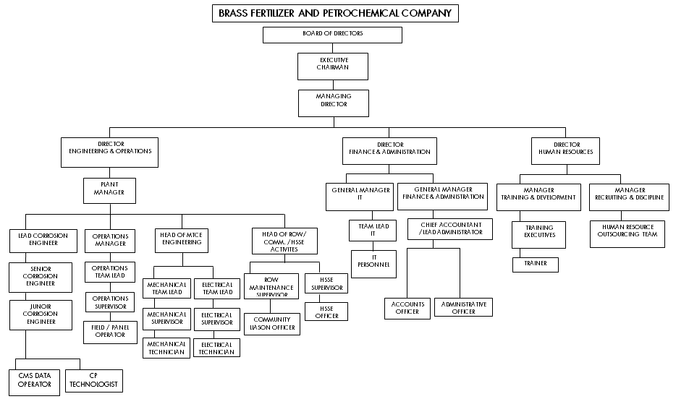
Figure 2.1: Organisational Structure of the Brass Fertilizer and Petrochemical Company Asset Management

  - Project Description
It is envisaged that the Brass fertilizer plant (owned by BFPC) will come into production in 2020 and later on to full capacity production of the following products:
- 1.75 MTPA of Methanol
- 2.6 MTPA of Urea
The petrochemical plant and its infrastructural facilities will be located, bordering the Atlantic Ocean in Brass Island, Bayelsa State of Nigeria. It will have facilities widely spread on both sides of the River Niger (West and East). The plant feedstock will be Wet Gas from SPDC-JV wells at BBOU, Nun River, Seibou and Opugbene fields.
The wet gas will be transported from SPDC’s wells through bulklines to the manifolds as shown in Red and Yellow colors, Figure 2.3. From the manifolds, the gas will then be dehydrated and fractionated to obtain dry gas and liquid products. The processed lean gas will then be transported to the Petrochemical and Power Plants as shown in the Fig.2.3;
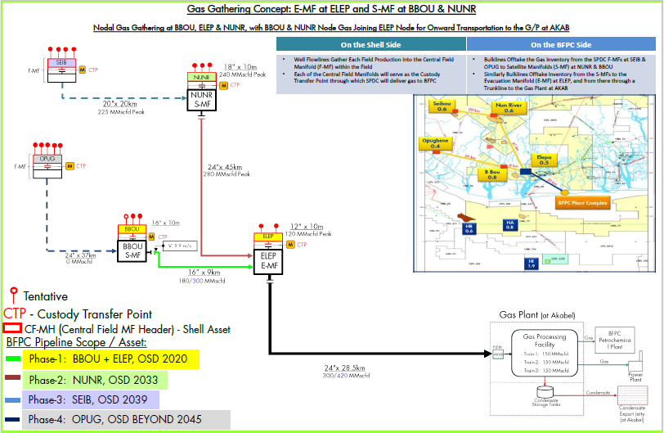
Figure 2.3: Wellhead Gas Gathering Schematics and Gas Process Flow Schematics to the Petrochemical Plant and Power Plant

- Infrastructural Support Strategy & Manning

  - Strategy for Base Facilities
The base facilities will contain infrastructures with all necessary utilities to facilitate efficient operational management of the assets. These facilities include the following:
- Housing for accommodating personnel.
- Buildings for operational activities such as, the control room, chemical shed, store for materials and consumables, Security post (for security operatives) within the Gas Processing Plant.
- Shelters for skids / unit equipment.
- Uninterrupted power supply system.
- Robust water supply / treatment system for use by personnel and fire fighting in case of fire.
- Drainage Systems for hazardous and non-hazardous wastes.
  - Strategy for Transportation to Remote Locations
Transportation of personnel to various remote manifold locations would be done with Diesel Engine-Driven boats through the creeks, for O & M activities.
  - Strategy for Operational Materials & Consumables
Material supplies for administrative and technical purposes should be inventoried and stocked in a store house. Materials to be stocked include but not limited to following:
- PPE such as hard hats, hand gloves, coveralls, safety shoes etc.
- Material and Computer consumables such as absorbent papers, cleaning chemical, printing papers and cartridges etc.
- Liquid chemicals such as de-emulsifiers, anti- freeze agents, liquid desiccants etc.

  - Strategy for Security Systems
Security systems should be kept in placed to safe guard the operational integrity of the assets and personnel against intrusion. The security within the project boundaries should be efficient, proactive, respond quickly to emergency situations. These systems include the following:
- Aerial surveillance with helicopters along the remote manifold locations and the Gas Processing and Power Plants.
- Security patrol team on boats and on-site within the project boundaries.
- Security Perimeter fence around major assets (Gas Processing, Petrochemical and Power Plants).
- Emergency alarms should be installed on every manifold and the Gas Processing Plant to alert personnel and security operatives of any abnormal situations.
- Devices such as CCTV cameras could also be incorporated at specific locations within the Gas Processing Plant and monitored from the Operations control room or a security control centre.
- Security awareness and emergency drills should be administered to both new and old personnel periodically.
  - Strategy for Pipeline Database Management System
The DBMS has to be efficient and effective in the organization of data. The DBMS should provide real-time assessment of planned activities, repair status, integrity status, historic information, trends and remaining life information of the assets.
A DBMS should provide the following functions, but should not be limited to:
- Concurrency; there should be concurrent access to the same database by multiple users.
- Security; it should have security rules to determine access rights of users.
- Backup and Recovery; there should be processes to back up and recover data regularly.
- Integrity; database structure improves the integrity of the data.
- Data Description; a data dictionary provides a description of the data.

    - Strategy for the Selection of Database
The strategy to be utilized in the selection of a robust single system that embraces all the required functionalities or a family of systems that are accessible to each other, which should include the following but not limited to:
- The Functionalities
- Data Storage Management
- Data Dictionary Management
- Data Transformation and Presentation
- Security Management
- Multiuser Access Control
- Backup and Recovery Management
- Data Integrity Management
- Database Access Languages
- Application Programming Interfaces
- Database Communication
- DBMS Quality Assessment Software Vendor Selection Process - ISO 9000:
- Vendor Stability
- Performance Evaluation
- On-Site Demo Evaluation
- System Risk Assessment / Analysis (SWOT – Strength, Weakness, Opportunities and Threats)
  - Operation and Maintenance Philosophy
This should be carried out in order to guarantee efficient, safe performance and continuous operations of the facilities.
The RRM (Risk and Reliability Management) will be utilized in reducing the probability and or consequences of a facility’s downtime to as low as reasonably practicable.

    - Documents for Operations and Maintenance Manual
The key documents that are needed to build up the O & M manual and maintain communication with key vendors are given as follows, but not limited to:
- Basis for Design which includes Operations, Safety, and Evacuation Philosophy.
- PFS / PEFS.
- Pipeline Specifications.
- Shore Section Specifications.
- Pipeline Coating Specifications.
- Specifications for Pipeline Cathodic Protection Inhibition.
- Soil Resistivity / Brackish water Resistivity Report.
- Valve Maintenance Manual.
- ESD / Instrumentation Manual.
- Equipment Vendor List and Vendor Information.
    - Operations Philosophy
- The operations personnel must monitor safe production parameters; pressure, flow rate, temperature and levels.
- Adjust temperature, flow rate, pressure as the operating limits change.
- Test safety system devices according to API RP 14C.
- All process operations such as; start up, shutdown, etc., shall be accompanied with standard operating procedures.
    - Maintenance Philosophy
- Calibrate production sales meter to ensure they are operating effectively and efficiently.
- Maintain equipment and safety devices to ensure they are operating according to manufacturer’s specifications.
- Concurrent production planning shall allow for shutdown of other facilities, and also, for services and repairs to be carried out simultaneously (e.g. TAM of main plant).

    - Abnormal Situation Management
This would aid the process system against undesirable plant disturbances by involving human intervention to supplement the actions of the process control system, to operate at normal conditions. A written document known as “Standard Operating Procedure” would be initiated to achieve proper operation of different process skids or units during abnormal conditions of the process system. Such situations should be carried out as follows:
- Respond appropriately to the occurrence of an abnormal situation with reference to the SOP of the affected equipment or process.
- Determine whether the equipment or the process is in abnormal mode and check for any latent abnormal conditions.
- Identify operational changes outside the operating envelop and respond to the occurrence of any abnormal situation in equipment and processes.
- Understand the correct impact or effect of a procedural action and the repercussions of not adhering to the SOP.
    - Emergency and Contingency Plan
The strategy for an emergency and contingency plan is to respond to the maintenance of unforeseeable consequences of integrity loss. The purpose is to provide necessary guidance, standards, procedure, organization and equipment to minimize the potential impact of asset integrity failure of pipelines on the health and safety of those that might be affected, the environment, asset value and the company’s reputation. The process concludes when control is restored on asset integrity, the social and natural environment and the company’s reputation.
There are two types of emergencies for which contingency planning, they as follows:
- Business emergencies: This could result from unexpected events, such as reduced production quota or budget cuts and other adverse environmental conditions having a negative effect on implementing the planned asset integrity work programme. If there is no effective response, this could deteriorate to a physical emergency.
- Physical Emergencies: This could occur when a failure causes immediate and partial or complete loss of the asset’s ability to perform its specified design and or operating function. Once physical emergencies occur, the emergency response system is activated.

  - Inspection and Maintenance Strategy
A reliability central approach which is geared towards proactive and non-breakdown strategy should be employed to ensure that breakdown shall not occur through:
- Effective, implementation for corrosion, inspection, and maintenance mitigation plan.
- The activity reference plan (ARP) comprising of MRP and ERP will be developed utilising frequency from statutory obligation, failure mode and effective analysis along aside the risk analysis to evolve the plan.
- Specific equipment and safety system monitoring requirement.
- Pipeline pigging and pigging procedure.
- Process start up.
- Emergency shutdown.
- Hazardous area compliance.
- Cathodic protection systems.
The Inspection and Maintenance Strategy will allow for:
- Internal corrosion inspection and mitigation including Inhibition Management.
- External corrosion inspection, mitigation and management system.
- Pipeline inspection, maintenance covering routine pigging and intelligence pigging.
- ROV monitoring and maintenance at the coastal line.
- CP system and Harco Tow Fish CP monitor at the coastal line.
- Site scanners survey at River Crossing.
- Riser inspection and maintenance at AKABEL.
- Valves, instruments and other ancillary equipment inspection and maintenance.
- Instruments for safe guarding the technical integrity as required.
- The chemical injection system inspection and maintenance.

  - Strategy for Safety Systems
Safety shutdown devices, alarm devices and pressure relief devices are for the protection of the personnel, the environment, equipment, and other associated facilities etc. They should not be bypassed or negated in any way. The key strategies are given below:
- Uncased equipment left in operation should be attended to urgently.
- Before restoring facility to its normal operating conditions, the operator responsible for engaging safety devices shall be present to ensure the system is operating as designed.
- With regards to HSE, the general hazards shall be identified for hydrocarbon content under pressure and appropriate tools to be used for O & M.
- Shutdown, start-up, normal and abnormal operations is managed with well established guidelines and procedures.
- Proper change control management must be in place.
  - Strategy for Communication Systems
The strategy for telemetry and communication systems should be developed by incorporating systems that would ensure efficient and effective communication among personnel and SCADA systems within the facility and to other remote locations. The recommended communication options are;
- Fibre optics: This is a fast, rugged and robust means of linking data gathering points to the collection center.
- Wireless communication: This involves using microwave wireless communications to link up the remote manifold platforms to the base control center. It has easy installation and also provides wider accessibility.
The key strategies to be followed during implementation of the communication systems are given below:
- The communication equipment to be installed must be robust to achieve high signal strength, speed, and bandwidth across the project boundaries.
- Communications across project boundaries must be secured, audible, have real-time flow of information, and have effective data transfer within and outside the facility which is important for safe and efficient operations.
- Communication devices such as walkie-talkies’, alarm systems, satellite phones must always be powered and safeguarded properly.
- New batteries should be kept on stand-by, to act as back-up to old ones being used in the communication devices.

  - Strategy for ROW, Elimination of Third Party Intrusion and Safety of Assets
The ROW is an easement, which in most cases is used to construct, operate, protect, inspect, maintain or replace pipeline and other infrastructural facilities.
The strategies that shall follow to maximize the effectiveness of the ROW for the purpose for which it is created will involve several protocols to overcome the problems as much as possible. The key strategies are given below:
- To obtain the ROW Agreement and the licence to operate on regular basis.
- Survey and re-establish the ROW boundaries as required by the law.
- Identify the ROW with warning signs as required.
- Maintenance of the ROW through continuous cutting of the grass and removal of all trees etc.
- Prevention of access into the ROW by intruders by having restrictions installed at all road crossings against vehicular, human and animal traffic.
- Surveillance on the ROW through:
  - Community liaison.
  - Security patrol.
  - Aerial surveillance identifying third party encroachment and other form of intrusions.
- Using technological monitoring system that have the following features, but not limited to:
  - Reliability: The system must provide consistent and reliable data. False alarms decreases the personnel’s confidence and farther the complacent monitoring.
  - Near-real-time Notification: The operations and security personnel must be able to respond to intrusion as it happens.
  - Precise Location: The system must pin-point the location of the intrusion.
  - Data Cataloguing.
  - Financial Feasibility of the System.

APPENDIX
- Wellhead Gas Gathering Schematics & Flow Parameters to Gas Processing Plant
- Proposed Pipeline Route
- Pipeline Materials Selection

Appendix-1: Well Gas Gathering Schematics
Appendix 1 | EA/SPDC-BFPCUGS-GEP/BDM-PFS-001-A01  Wellhead Gas Gathering Schematics & Flow Parameters to Gas Processing Plant

Appendix-2: Proposed Pipeline Route
Appendix 2 | EA/SPDC-BFPCUGS-GEP/SUY-DWG-001-A01  Proposed Pipeline Route

Appendix-3: Pipeline Materials Selection
Appendix 3 | EA/SPDC-BFPCUGS-GEP/BDM-SCH-001-A01 Pipeline Materials Selection & Manifold Platforms Footprint Indication. BBOU & ELEP

